CEN3907C

7 October 2024

**GatorBall Design Draft**

Tyler Burndt | Andrew Miller | Ricardo Nivar-Cortes | Augustus Rodriguez | Joshua White

**Introduction**

Purpose / Need:

This product is intended for football enthusiasts to accurately track first-downs without the need for a referee. It is needed because having a referee step out onto the field to manually measure the football and determine if a first-down has been established greatly slows down the momentum of the game and is also cumbersome to do. Our product will resolve this issue by providing an effortless way of tracking first-downs without the need for any human intervention. This product is primarily intended for small-scale football games like flag football or, potentially, intramural-level games.

Domain & Prior Art:

Existing work similar to our product is used heavily in the NFL [1]. The NFL embeds RFID tags in player uniforms as well as the football itself. These RFID tags are extremely lightweight and unobtrusive, so they have a negligible impact on gameplay. The data collected by these tags allows the NFL to track statistics such as ball height, position, velocity, as well as player speed, passing rates and much more. These statistics greatly enhance the quality of the game and allow for the NFL as well as football enthusiasts at home to deep-dive into player stats. Our product, on the other hand, will focus specifically on the ball position to allow us to determine if a first-down has been made.

Impact & Risk Assessment:

The impacts of this product are limited to within the game of football, which is nonetheless an important institution in our local culture. By eliminating manual measurements in the game it becomes more efficient and quicker to run. This may have the effect of making the game easier to watch and therefore more popular, changing its role in our culture. By saving on the labor costs of taking these measurements, football leagues will benefit economically, although this comes at the cost of the jobs lost due to the technology. Some football fans might also consider the use of the technology inauthentic to the game; such a cultural impact to the sport itself might not be assessable without having to introduce the technology.

**Statement of Work:**

Milestones -

* Semester 1: Design revision (Week 8), Pre-Alpha build (Week 10/11), Design Prototype (Week 13/14), Design Prototype Presentation (Week 14/15)

Core Features-

* Ultra-wideband (DWM 3000) controlled with a microprocessor (ESP32-C3) within the football to gather and relay positional data to anchors
* Anchors within each end-zone to triangulate position of the football using UWB with microprocessor controller (ATXmega)
* User facing application to display data and show location of spot for the football
* Communication protocols over Bluetooth for user data transmission and UWB in order to gather positional data
* Positional data accurate to within <10 cm to ensure proper spots.
* Fast accurate triangulation of location.

Secondary Features-

* Positional data accurate to within <3 cm ideally for accurate placement and use within professional settings
* 2 anchors within each end zone to reduce costs and computation
* Error detection for wireless communication

Performance Specifications -

* Operation Voltage - 3.3V for all microprocessors and DWM
* Power Consumption - 250mW for DWMs, 80mW for ESP32-C3, 100mW for ATXmegas
* Bandwidth - 850kbps-6.8Mbps for DWM
* Connectivity- SPI Communication between microcontroller and DWMs, UWB for communication between anchors and ball. Bluetooth connection to main computer running computation.
* Languages and Software - C/C++ for running microcontrollers and on the main computer. JS/HTML/CSS for web application.

Milestone Goals for Semester 1 -

* Design Revision - Improve on our product roadmap and further research and revision towards planning our project.
* Pre-Alpha Build - Provide a clear foundation for the products infrastructure and architecture, research, design and experimentation on potential solutions to ensure communication between the microprocessor, location relays for collection of positional data and user devices to show the data they need. Have basic operations for triangulation done.
* Design Prototype - Demonstrate the core features and feasibility of our product, namely UWB communication between the football and locational relays to be able to show position and display data.
* Prototype Presentation - Outline current status and future goals of the project moving into semester 2. Including a prototype demonstration and deliverable plan to complete final deliverable.

**Deliverable Artifacts:**

At the end of the project, our team will deliver a package composed of a few different artifacts. The hardware we will deliver at the end of the project will be a microprocessor that continuously collects positional data (and potentially velocity and rotational inertia) from a transponder (DW3000 module). The software we will deliver will include the code we use to accomplish this as well as user-friendly documentation that outlines how to set up and use the product.

**For software/documentation, dissemination plan: format and distribution of project**

Our project is planned to be implemented in fields and stadiums by us and the data gathered would be sent to referees to be used during games and testing. The footballs will also be modified by us by placing the PCB generated to enable UWB communication inside, with the microcontroller programmed to communicate. To ensure proper function of the systems, referees can test the position by placing a football at different locations on the field and verifying through software that the position is correct. For maintenance, each field/stadium will have multiple balls, depending on the level of play it could be 10-100+ balls, and if one breaks or has issues they can be replaced before the game is affected. These balls then could be sent back to be repaired if damages aren’t too heavy.

**Mockups**

Interfaces/Systems/Networking:

Physical/Graphical Interface - The live location of the football will be displayed on a computer screen via a web based interface. On this interface, the user will be able to see a 2D representation of a football field along with the football’s current location, the line of scrimmage (highlighted red), and the first down line (highlighted yellow). Additional information such as yardage-to-gain, play clock, game clock, etc. will also be displayed on the screen. (This display screen is located in the storyboards section)

Programming Interface - There will be 3 DWM3000 modules present in our design: two acting as anchor points in each end zone and one within the football. These three modules will communicate via ultra wideband signals to triangulate and track the location of the football during the game. The two modules acting as anchor points will have ATXMega controllers to control the signal inputs/outputs via SPI. The module that’s located in the football will be connected to the ESP32 via SPI and track the current position of the football. Lastly, the processor will be connected to an output device (laptop, CPU, mobile, etc.) via Bluetooth (BLE) where the data will be displayed, stored, and manipulated.

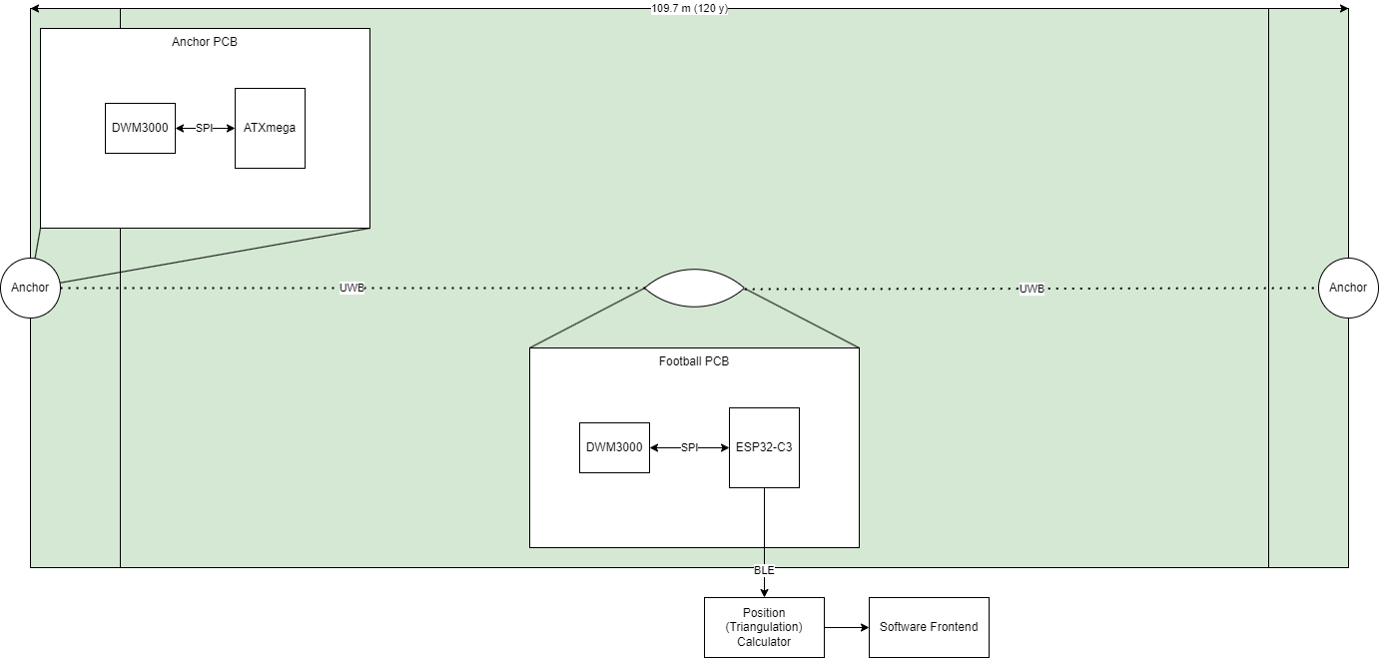

Storyboards:

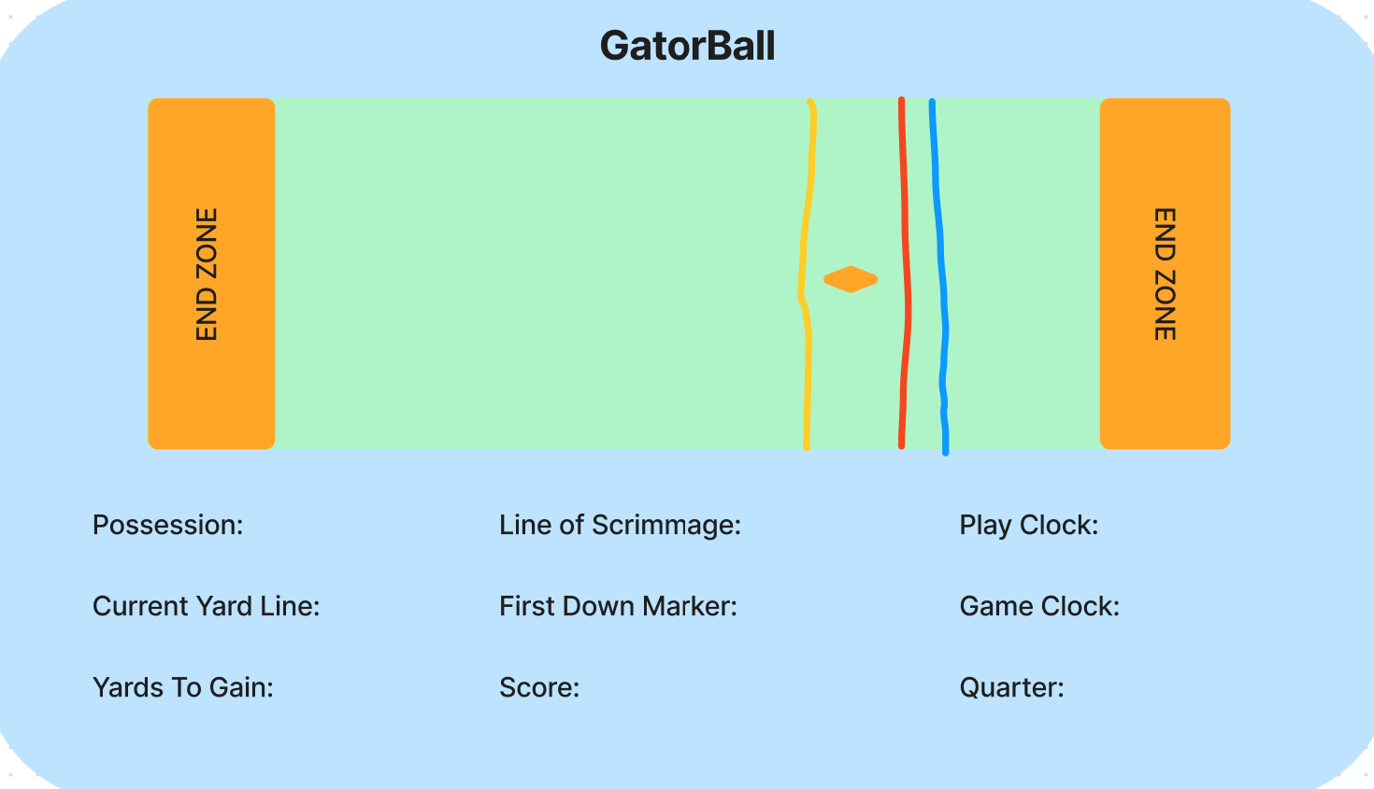

The image above is the screen on which our data would be displayed. The location of the football is represented by the horizontal diamond and will update live throughout the course of the game. Referees will also be able to view information pertaining to the game itself through this screen. The different colored lines located on the football field are representative of different markers: the yellow line is the first down marker, the red line is the line of scrimmage, and the blue line is the current down marker.

Draft Schematics:

Below is how we will connect the DW3000 and ESP-32 in order to use SPI to communicate between the two chips inside the football. The DW3000 will take the information from the anchor points and send the data through SPI to the ESP_32 microcontroller which will do the calculations and send data to the computer program to the referee. We will use general I/O pins on the DW3000 to connect to the SPI of the ESP32. We will connect the SPID to GPIO3 for the MOSI, SPIQ to GPIO2 for MISO, GPIO1 to SPICLK for the SCK, and GPIO0 to SPICS0 for SS.

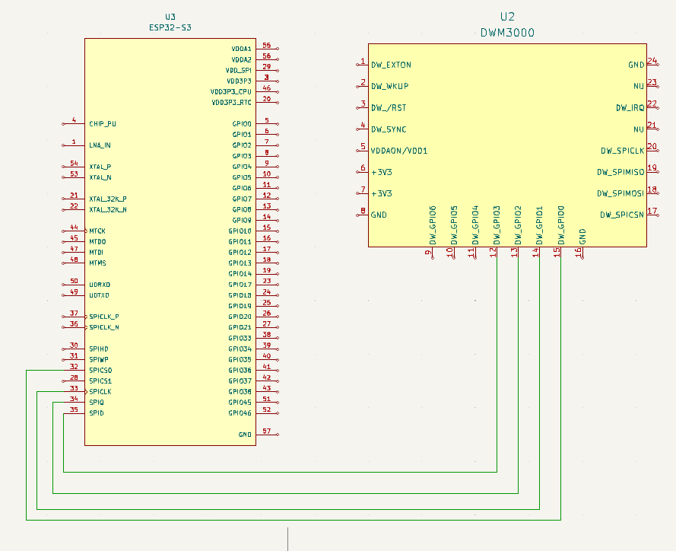

For the anchor points we will be using the ATxmega128A1U as the microchip to connect to the DW3000. We will use the same pins for the DW3000 as used above but for the ATxmega we will use pins corresponding to PORTC as it has SPI capability. For PORTC we will make PC3 for MOSI, PC2 for MISO, PC1 for SCK, and PC0 for the SS. Below is how we will wire the DW3000 to the ATxmega.

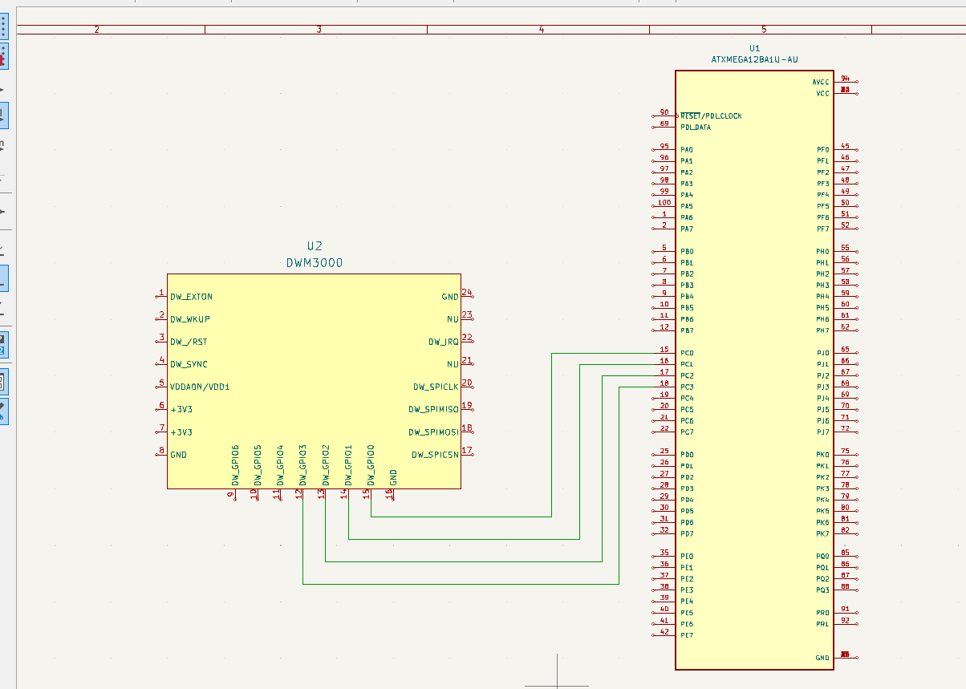

**Sources:**

**[1]** [**https://www.engineering.com/the-technology-behind-the-nfls-incredibly-precise-stats/**](https://www.engineering.com/the-technology-behind-the-nfls-incredibly-precise-stats/)

**Final design (for now):**

[**https://www.makerfabs.com/esp32-uwb-dw3000.html**](https://www.makerfabs.com/esp32-uwb-dw3000.html) **| anchors**

[**https://www.qorvo.com/products/p/DWM3000**](https://www.qorvo.com/products/p/DWM3000) **| transponder; we will fit this on to a custom PCB to minimize the footprint of the physical component inside the football since we don’t need a lot of the features from the microcontroller linked above.**

[**https://www.espressif.com/sites/default/files/documentation/esp32_datasheet_en.pdf**](https://www.espressif.com/sites/default/files/documentation/esp32_datasheet_en.pdf) **| ESP-32 datasheet**

[**https://ww1.microchip.com/downloads/en/DeviceDoc/atmel-8385-8-and-16-bit-avr-microcontroller-atxmega64a1u-atxmega128a1u_datasheet.pdf**](https://ww1.microchip.com/downloads/en/DeviceDoc/atmel-8385-8-and-16-bit-avr-microcontroller-atxmega64a1u-atxmega128a1u_datasheet.pdf) **| ATxmeaga128 datasheet**

[**https://www.qorvo.com/products/p/DW3110#documents**](https://www.qorvo.com/products/p/DW3110#documents) **| DW3000 Documents**

[**https://www.figma.com/board/rOKxpPEDzPgp7Nbc284U8L/GatorBall-Display-Screen?node-id=0-1&node-type=canvas&t=yHCNVF4kEPrvkOHl-0**](https://www.figma.com/board/rOKxpPEDzPgp7Nbc284U8L/GatorBall-Display-Screen?node-id=0-1&node-type=canvas&t=yHCNVF4kEPrvkOHl-0) **| Storyboard (Display Screen)**